Homework 9: Bootstrapping (Solutions)

Oliver d’Pug

## Create a **b.var** function

I’m lazy and will use the **boot** package to run my bootstrap. I need a function that computes the variance that can be passed to the **boot** function.

b.var = function(d, i){  
 var(d[i])  
 }

## Create a dataset of 100 normal observations

args(rnorm)

function (n, mean = 0, sd = 1)   
NULL

n = 100  
 mu = 2  
 sig = 7  
 normal_data = rnorm(n, mu, sig)  
 write.csv(normal_data, "hw9_normal_data.csv")  
 c(summary(normal_data), var_x=var(normal_data), sd_x=sd(normal_data))

Min. 1st Qu. Median Mean 3rd Qu. Max. var_x   
-21.993247 -2.073824 3.010643 3.130375 8.066483 17.262490 52.399774   
 sd_x   
 7.238769

### Bootstrap the variance using **b.var**

### Use the boot function to run the bootstrap  
 normal_b.var = boot(normal_data, b.var, R=9999)  
 normal_b.var

ORDINARY NONPARAMETRIC BOOTSTRAP  
  
  
Call:  
boot(data = normal_data, statistic = b.var, R = 9999)  
  
  
Bootstrap Statistics :  
 original bias std. error  
t1* 52.39977 -0.524394 8.152271

### How much bias does the estimate have? Is the bootstrap distribution normal or chisquare?

attributes(summary(normal_b.var))

$names  
[1] "R" "original" "bootBias" "bootSE" "bootMed"   
  
$row.names  
[1] 1  
  
$class  
[1] "summary.boot" "data.frame"

summary(normal_b.var)

R original bootBias bootSE bootMed  
1 9999 52.4 -0.52439 8.1523 51.345

plot(normal_b.var)

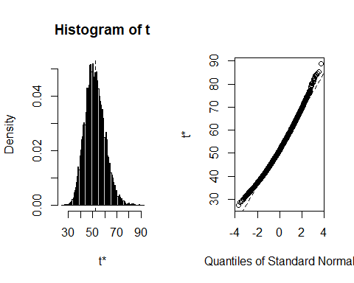

qqPlot(normal_b.var$t, distribution="norm")

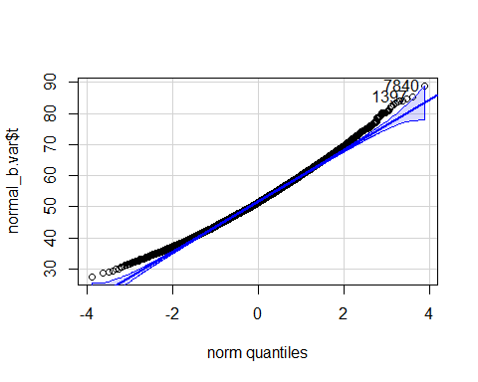

[1] 7840 1397

qqPlot(normal_b.var$t, distribution="chisq", df=n-1)

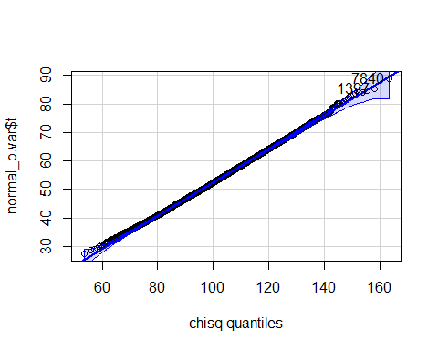

[1] 7840 1397

The variance estimator appears to have bias=-0.524394 and SE=8.1522711 when the data consist of 100 observations randomly drawn from a normal with mean $μ=$ 2 and variance $σ^{2}=$ 49. The variance appears to be neither normally nor chisquare distributed, although the chisquare may fit a bit better.

## Create a dataset of 100 standard normal observations

args(rnorm)

function (n, mean = 0, sd = 1)   
NULL

n = 100  
 mu = 0  
 sig = 1  
 std_normal_data = rnorm(n, mu, sig)  
 write.csv(std_normal_data, "hw9_std_normal_data.csv")  
 c(summary(std_normal_data), var_x=var(std_normal_data), sd_x=sd(std_normal_data))

Min. 1st Qu. Median Mean 3rd Qu. Max.   
-3.33324516 -0.62310758 0.02923251 -0.01607254 0.66450345 2.78512838   
 var_x sd_x   
 1.10213077 1.04982416

### Bootstrap the variance using **b.var**

### Use the boot function to run the bootstrap  
 std_normal_b.var = boot(std_normal_data, b.var, R=9999)  
 std_normal_b.var

ORDINARY NONPARAMETRIC BOOTSTRAP  
  
  
Call:  
boot(data = std_normal_data, statistic = b.var, R = 9999)  
  
  
Bootstrap Statistics :  
 original bias std. error  
t1* 1.102131 -0.008390659 0.1827047

### How much bias does the estimate have? Is the bootstrap distribution normal or chisquare?

summary(std_normal_b.var)

R original bootBias bootSE bootMed  
1 9999 1.1021 -0.0083907 0.1827 1.0841

plot(std_normal_b.var)

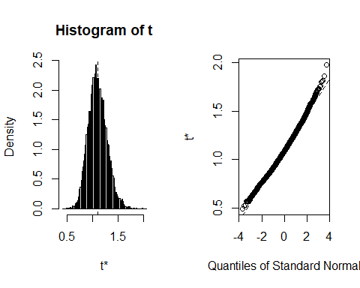

qqPlot(std_normal_b.var$t, distribution="norm")

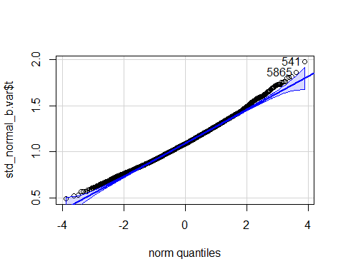

[1] 541 5865

qqPlot(std_normal_b.var$t, distribution="chisq", df=n)

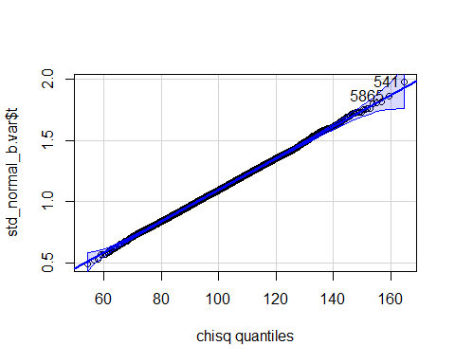

[1] 541 5865

The variance estimator appears to have bias=-0.0083907 and SE=0.1827047 when the data consist of 100 observations randomly drawn from a normal with mean $μ=$ 0 and variance $σ^{2}=$ 1. The variance appears not to be normally distributed. However, it appears to have a chisquare distribution. The MGF of the sum of squared standard normals supports this contention.

## Create a dataset of 100 U(0,1)

args(rnorm)

function (n, mean = 0, sd = 1)   
NULL

n = 100  
 a = 0  
 b = 1  
 unif_data = runif(n, a, b)  
 write.csv(unif_data, "hw9_unif_data.csv")  
 c(summary(unif_data), var_x=var(unif_data), sd_x=sd(unif_data))

Min. 1st Qu. Median Mean 3rd Qu. Max.   
0.001091276 0.173983906 0.424912276 0.442482873 0.679215578 0.973776141   
 var_x sd_x   
0.090396014 0.300659298

### Bootstrap the variance using **b.var**

### Use the boot function to run the bootstrap  
 unif_b.var = boot(unif_data, b.var, R=9999)  
 unif_b.var

ORDINARY NONPARAMETRIC BOOTSTRAP  
  
  
Call:  
boot(data = unif_data, statistic = b.var, R = 9999)  
  
  
Bootstrap Statistics :  
 original bias std. error  
t1* 0.09039601 -0.0009440588 0.007664379

### How much bias does the estimate have? Is the bootstrap distribution normal or chisquare?

summary(unif_b.var)

R original bootBias bootSE bootMed  
1 9999 0.090396 -0.00094406 0.0076644 0.089403

plot(unif_b.var)

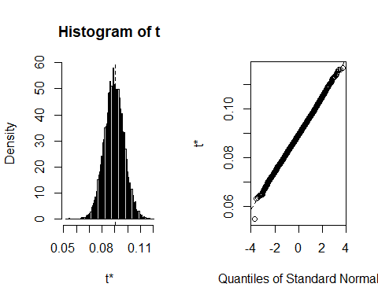

qqPlot(unif_b.var$t, distribution="norm",)

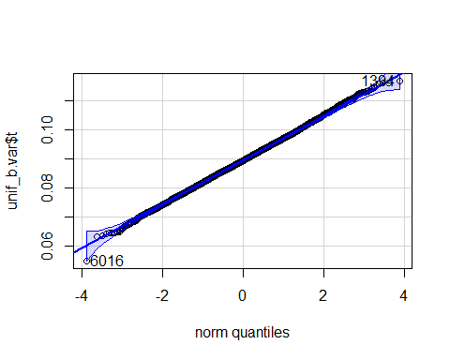

[1] 6016 1394

qqPlot(unif_b.var$t, distribution="unif", min=a, max=b)

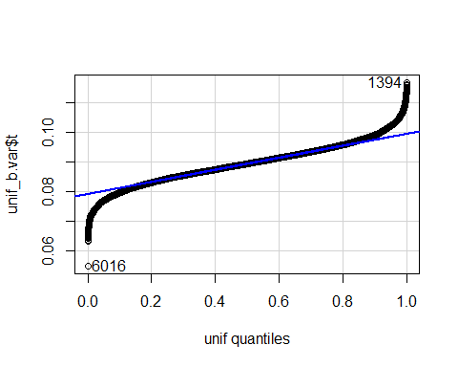

[1] 6016 1394

qqPlot(unif_b.var$t, distribution="beta", shape1=(3*n-1)/2, shape2=(3*n-1)/2)

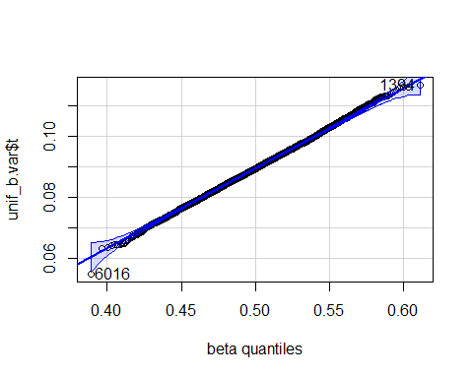

[1] 6016 1394

When the data consist of 100 observations randomly drawn from a U( 0 , 1), the variance estimator appears to be unbiased as bias=-9.4405878^{-4}. The standard error is SE=0.0076644. The variance appears to be somewhat normally distributed, but it is not U( 0 , 1) distributed. For appropriately chosen shape parameters, $α$ and $β$, the distribution of the variance appears to be almost beta.